TOGETHER - Week 3 Guide
Opening Prayer: Share a short prayer, reflection or spontaneous prayer.
Introductions: Share your name and one highlight from the week.
Check In: Giving Yourself Grace
A. Review How-to's Using Google Meet Platform
Confidentiality
Camera
Mute/Unmute
Contribute & Encourage
Connect
B. Introduce PMS Discussion
How are you feeling PHYSICALLY, MENTALLY, SPIRITUALLY?
C. Follow Up ?
How are you giving yourself grace? How are you giving your family or children grace? Self care is important. What are some "best practices" you find have been helpful in taking care of yourself?
If you could make a goal in one of these areas this week, what could it be?
Inspiration from the Saints: Share the reflection materials from the great Saint of our faith by using the following "lectio" inspired process to reflect as a group.
First, read the information on the first page to introduce the Saint's story. Together, read and reflect on the quotes provided. Invite everyone to listen for a word or phrase from this Saint that may inspire them at this time.
Second, share these words and phrases with one another.
Third, reflect and share how Jesus might be speaking to you through this reflection
Intercessory Prayer: Invite everyone to share prayer together. Open the floor for everyone to take turns sharing (no need to popcorn! Just unmute and share!) and give it a good 30-50 seconds before you wrap everything up. The delays with muting/unmuting can take a little more time than in-person prayers. Close with the Weekly Saint Prayer provided or another prayer of your choice.
TOGETHER Week 3 Reflection

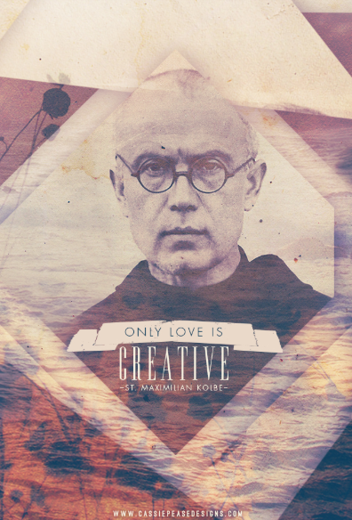

Saint Maximilian Kolbe

Love never rests, but spreads like a consuming fire.

At the age of sixteen, Maximilian entered the Franciscans, monks who live in poverty like Saint Francis. He became a priest and went all the way to Japan, founding communities in honor of the Blessed Virgin. After his return home to Poland, the Second World War broke out: the Nazis sent Jews and those who resisted to concentration camps. Arrested and beaten, Father Kolbe was sent to Auschwitz. There he had to let go of his Franciscan robes for the prisoner's striped uniform. In the camp, he comforted and restored peace to those around him. One day, when several people were to be executed, Father Kolbe asked to die in place of the father of a family. He gave up his life for him, just as Jesus did for us.

Ask Saint Maximilian to help you to remain at peace when you go through difficult times. He often said: "Give yourself to others!" For him, that was the road to joy! Like him, you can entrust all the little details of your life to Mary.

Quotes For Discussion

“Let us not forget that Jesus not only suffered, but also rose in glory; so, too, we go to the glory of the Resurrection by way of suffering and the Cross.”

“For Jesus Christ I am prepared to suffer still more.”

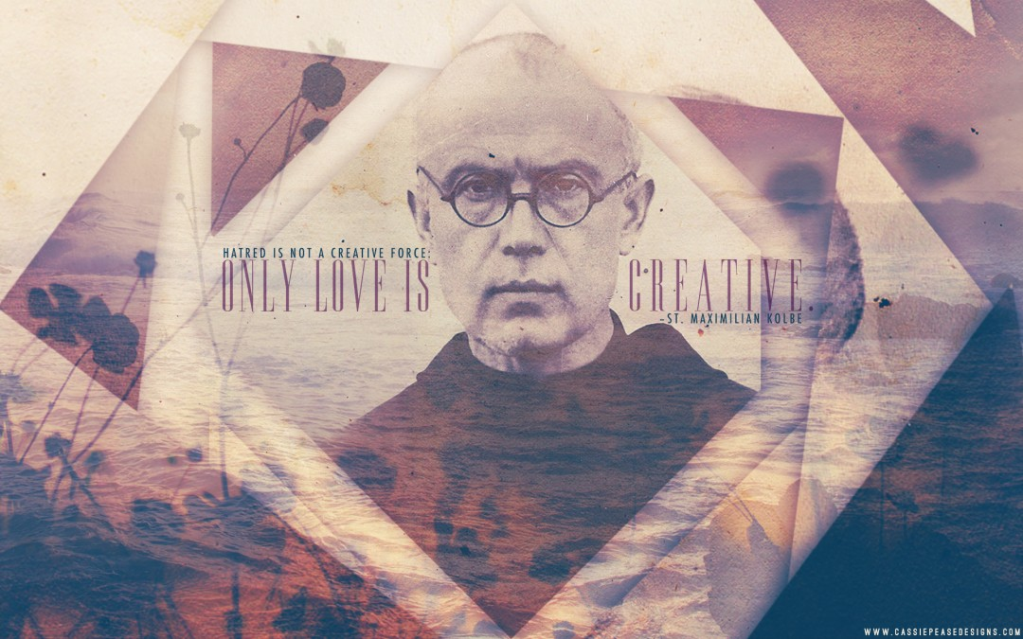
Prayer
O Mary, Immaculate Virgin,
chosen among all women
to give birth to the Savior,
you who were the faithful servant of the Lord,
help us to answer the call of Jesus
and follow him on the path of life that leads to the Father.

Grant that our lives witness to the Gospel
in the midst of this world in search of the light.

Oh Mother of Jesus,
may all of creation join you in praise of God for his mercy and infinite love.

Amen
(Based on a prayer of Saint Maximilian Kolbe)

Prayer of Consecration: Maximilian Kolbe, whose life illustrated such love, I beseech you to grant my petitions. ... Grant O Lord Jesus, that I too may give myself entirely without reserve to the love and service of my Heavenly Queen in order to better love and serve my fellow man in imitation of Your humble servant, St. Maximilian Kolbe.

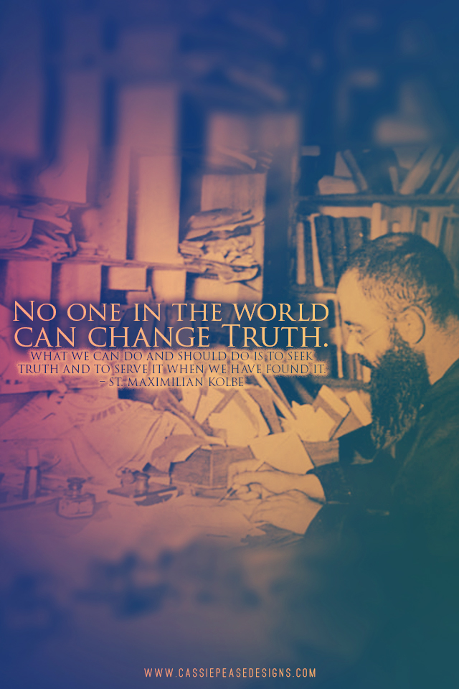

Additional Information: St Maximillian Marie Kolbe
https://epicpew.com/saintmaximiliankolbequotes/

January 8, 1894, Zdunska Wola, Poland-August 14, 1941, Auschwitz Concentration Camp
Feast Day: August 14
Patronages: Families, imprisoned people, amatuer radio operators, journalists, political prisoners

2
- Saint Maximilian Maria Kolbe was a Polish Franciscan friar. 79 years ago, he died as a martyr in Auschwitz. He was well known for his passionate devotion to Our Lady and his love for missionary work.
- When he was 12 years old, he had a vision of Mary, leading to a life-long passion to encourage people to venerate Mary, whom he called Imaculata, and perpetual adoration. He later recounted his vision: “That night I asked the Mother of God what was to become of me. Then she came to me holding two crowns, one white, the other red. She asked me if I was willing to accept either of these crowns. The white one meant that I should persevere in purity and the red that I should become a martyr. I said that I would accept them both.”^{[7]} wikipedia
- St Maximillian operated an amatuer radio station, SP3RN. He also formed the Militia Immaculata, and published a magazine, Knight of the Immaculate. He founded a publishing house in 1922, and a Fransiscan Monastery in 1927.
- From 1920-1933 Kolbe was a missionary in Japan, starting a Fransiscan Friary near Nagasaki, and Japanese versions of his magazine and newspapers.
- During the war, his monastery was a hiding place for 2,000 Jews. The monastery also housed a printing press, which produced anti-Nazi newspapers as well as radio broadcasts.
- On February 17, 1941, Father Kolbe was arrested and sent to the Auschwitz concentration camp. He was beaten and treated poorly due to his status as a Catholic priest. One night, three prisoners escaped the camp. After forcing the prisoners to stand outside, the guards began to select ten men who would be put in a bunker to starve to death. One man who was selected was a father and husband. As he was being led away, he cried, “My wife! My children!” Father Kolbe volunteered to take his place.
- Father Kolbe led his fellow prisoners in worship and songs as they suffered in the underground bunker. After two weeks without food and water, Father Kolbe was killed by an injection of carbolic acid. Saint Pope John Paul II canonized Father Kolbe in 1982, naming him a martyr of charity. The Catholic Church celebrates his feast day on August 14.
- There is a parish in Sobieski WI named after St Maximillian, and it is served by the Fransiscans in our diocese.
The Militia Immaculata is still active today, you can find them online! https://miyouth.org/ is one example

