TOGETHER - Week 2 Guide
Opening Prayer: Share a short prayer, reflection or spontaneous prayer.
Introductions: Take one minute to grab a special photograph. Share your name and tell us the story behind the picture.
Check In: All About Balance
A. Review How-to's Using Google Meet Platform
Confidentiality
Camera
Mute/Unmute
Contribute & Encourage
Connect
B. Introduce PMS Discussion
How are you feeling PHYSICALLY, MENTALLY, SPIRITUALLY?
C. Follow Up ?
What are some "best practices" you have found to stay physically or spiritually fit while we have been "staying at home?" How are you prioritizing faith/self, relationships, family or work?
If you could make a goal in one of these areas this week, what could it be?
Inspiration from the Saints: Share the reflection materials from the great Saint of our faith by using the following "lectio" inspired process to reflect as a group.
First, read the information on the first page to introduce the Saint's story. Together, read and reflect on the quotes provided. Invite everyone to listen for a word or phrase from this Saint that may inspire them at this time.
Second, share these words and phrases with one another.
Third, reflect and share how Jesus might be speaking to you through this reflection
Intercessory Prayer: Invite everyone to share prayer together. Open the floor for everyone to take turns sharing (no need to popcorn! Just unmute and share!) and give it a good 30-50 seconds before you wrap everything up. The delays with muting/unmuting can take a little more time than in-person prayers. Close with the Weekly Saint Prayer provided or another prayer of your choice.
TOGETHER Week 2 Reflection

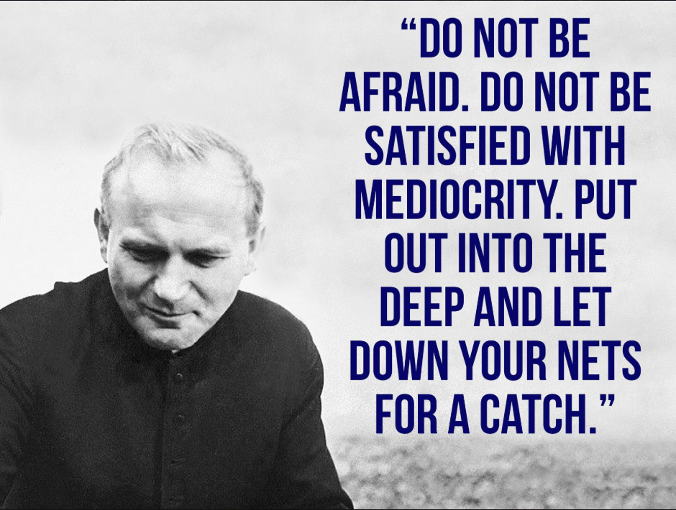

Saint John Paul II

If you follow Christ, you willfully develop the potential within you.

Karol Wojtyla was from Poland. When he was young, he lost his mother, and then later his brother, too. He was brought up by his father, who was a devout Christian. When the Germans invaded Poland in World War II, his father fell ill and died. Karol found himself alone in the world. It was wartime, and his country was overrun first by the Nazi occupation and then by a Communist dictatorship. Karol became a priest, then a bishop, and fought for justice and peace. In 1978, he was elected pope and, until his death in 2005, he traveled the world, defending the family and the sanctity of life. He constantly repeated that life is sacred and that we must care for the most vulnerable among us, from the timy baby in his mother's womb to the very elderly and sick. Pope Francis declared him a saint in 2014!

You can ask Saint John Paul II to give you the courage to defend the littlest and the most frail. He helps us to work for peace, starting within our own family. He teaches you to chase away fear to follow Jesus.

Quotes For Discussion

From now on it is only through a conscious choice and through a deliberate policy that humanity can survive. - Pope John Paul II

To maintain a joyful family requires much from both the parents and the children. Each member of the family has to become, in a special way, the servant of the others.

Freedom consists not in doing what we like, but in having the right to do what we ought.

Do not abandon yourselves to despair. We are the Easter people and hallelujah is our song. Pope John Paul II
Read more at https://www.brainyquote.com/authors/pope-john-paul-ii-quotes

Pope John Paul II was having trouble in math as a young boy; his father showed him the text of this hymn. In 1980, Pope John Paul shared with a group that he started praying this hymn every day since the age of 9. SING ALONG;)
Come, Holy Spirit, Creator blest, and in our souls take up Thy rest;
come with Thy grace and heavenly aid to fill the hearts which Thou hast made.
O comforter, to Thee we cry, O heavenly gift of God Most High,
O fount of life and fire of love, and sweet anointing from above.
Thou in Thy sevenfold gifts are known;
Thou, finger of God’s hand we own;
Thou, promise of the Father,
Thou Who dost the tongue with power imbue.
Kindle our sense from above, and make our hearts o’erflow with love;
with patience firm and virtue high the weakness of our flesh supply.
Far from us drive the foe we dread, and grant us Thy peace instead;
so shall we not, with Thee for guide, turn from the path of life aside.
Oh, may Thy grace on us bestow

Prayer
O Mary, Mother of the living,
to you do we entrust the life of every person:
of little babies still in the mother's wombs,
of all little children and families,
of the poor whose lives are made difficult,
of men and women who are victims of violence,
of those who, listening to your voice, work for peace,
of the elderly and the sick who are so frail.

Grant that all who believe in your Son, Jesus,
may proclaim the Gospel of Life.
Give them the courage to build,
together with all people of good will,
a world of truth and love to the praise and glory of God,
the Creator and Lover of Life.

Amen
(Based on a prayer of Saint John Paul II)
