TOGETHER Week 1 Reflection

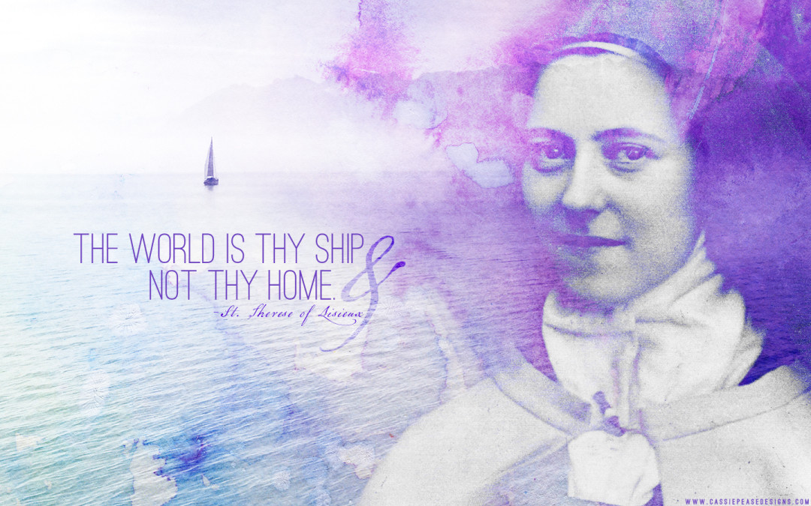

St Therese of Lisieux
Therese of the Child Jesus, of the face of Jesus
The Little Flower The Little Way

To love is to give everything and to give oneself.

Therese was the youngest of a family of five girls. At the age of four, she lost her mother and became very delicate: she was often in tears and constantly craved attention. Her sister Pauline became her second mother. When Pauline entered a Carmelite convent, Therese was sick with sorrow, but she was miraculously healed. All her sisters became nuns, and Therese herself felt the call of God at a very young age. She wished to give her all to him. So, at fifteen, she entered Carmel. For her, what mattered was to do little things with great love. To be childlike, that was her secret! Therese accomplished no great feats in the convent, and yet, after her death, her love of Jesus touched thousands of hearts: she is a friend to all, even to those who are far from the faith!

Therese can help you put love into the simplest of things: in your daily chores, as you enjoy a landscape, as you play, fix a meal, sing, help others, or just listen to a friend.

Quotes For Discussion

Love proves itself by deeds, so how am I to show my love? Great deeds are forbidden me. The only way I can prove my love is by scattering flowers and these flowers are every little sacrifice, every glance and word, and the doing of the least actions for love.

I will seek out a means of getting to Heaven by a little way—very short and very straight little way that is wholly new. We live in an age of inventions; nowadays the rich need not trouble to climb the stairs, they have lifts instead. Well, I mean to try and find a lift by which I may be raised unto God, for I am too tiny to climb the steep stairway of perfection. [...] Thine Arms, then, O Jesus, are the lift which must raise me up even unto Heaven. To get there I need not grow. On the contrary, I must remain little, I must become still less.^{[67]}

“It is better to leave each one in his own opinion than to enter into arguments.”

“If I did not suffer simply from moment to moment, I would find it impossible to be patient, but I look only at the present, forget the past and am careful never to anticipate the future. When we surrender to discouragement or despair it is usually because we are thinking too much of the past or the future.”

“Sufferings gladly borne for others convert more people than sermons.”

“Jesus, help me to simplify my life by learning what you want me to be and becoming that person.”

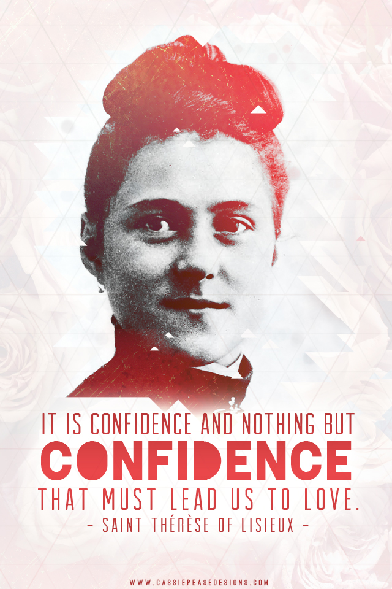
Prayer
My God, I offer you all my actions of this day.
I wish to sanctify each and every heartbeat,
Every thought, every simple little action,
By joining them to Jesus;
And I desire to make reparation for my sins
By casting them into the furnace of his merciful love.

Oh my God, for myself and for all my dear ones,
I implore the grace to fulfill perfectly your holy will
And to accept for love of you
All the joys and sorrows of this passing life,
So that one day we may be united in heaven for all eternity.

Amen
(Based on the prayer of Saint Therese)
For More Information
Reflection on St. Therese by Bishop Robert Barron
https://www.youtube.com/watch?v=03czgO8XUTg
Therese was born in Alencon France on 1/2/1873, the last of nine children. Four older siblings died in childhood, leaving 5 daughters, all who eventually became Carmelite Sisters.
She was raised in a very devout home; her father had hoped to become a monk but was not allowed into the order and her mother hoped to become a saint. When they married, they initially decided to live together celibately, but prayer revealed to them that they were called to have children. They poured their love into their children, and gave them strict religious instruction.

Therese was very spoiled, her nickname from her father was “little queen”. Her mother died when she was 4 ½, and she struggled emotionally until the age of 13, when she experienced a great act of maturity, which she called “her conversion”. She began to see that she was called to live for others, not herself.

When Therese was 9, she became very ill. She is placed in her older sister’s room with a statue of Mary. Her sisters are praying to Mary for her health, and she begins to pray as well. Therese sees Mary smile at her, and she regains her health.

Her father and sister take her on a tour of Italy when she is 13, and when they are in Rome, she has an opportunity to meet Pope Leo XIII. Therese had been trying to gain entrance into the Carmelite Order at Lisieux where her oldest sister is a sister, but she was turned away because she was only 13. Therese falls down in front of Pope Leo XIII and asks him to let her into the order. His response is to do what she is told, “you will enter if God wills”.

When she enters the Carmel at Lisieux, she continues to realize that she must empty herself of herself, and fill herself with Jesus. She begins on her journey of the “LITTLE WAY”. She sets her mind to making as many small sacrifices as possible: she takes the worst tasks, eats the worst food, smiles at anyone who is cranky or mean to her, sits next to the ornery sisters, etc.

One of Therese’s ambitions was to be a missionary to a foreign country, as the 1800’s are a great missionary age. She decides to pray for missionaries and write letters to encourage them as her way to be a missionary.

Therese contracts tuberculosis, and suffers terribly for several years. She died on September 30, 1897. Her spiritual model of the “little way” became so popular that she is canonized only 28 years after her death. St Therese’s parents are the only couple to canonized together.
When it becomes clear that she is dying, her sister asks her to write her autobiography. She keeps a journal, and her sister edits that into the autobiography: The Story of a Soul. There are 36 people with the title: Doctor of the Church; St Therese is one of 4 women.

Resources: Catholic Saints for Children - Magnificat Ignatius, www.caseypeasedesigns.com

